# C3- S7 PRACTICE

# Ex 1: Can I go to PNC?

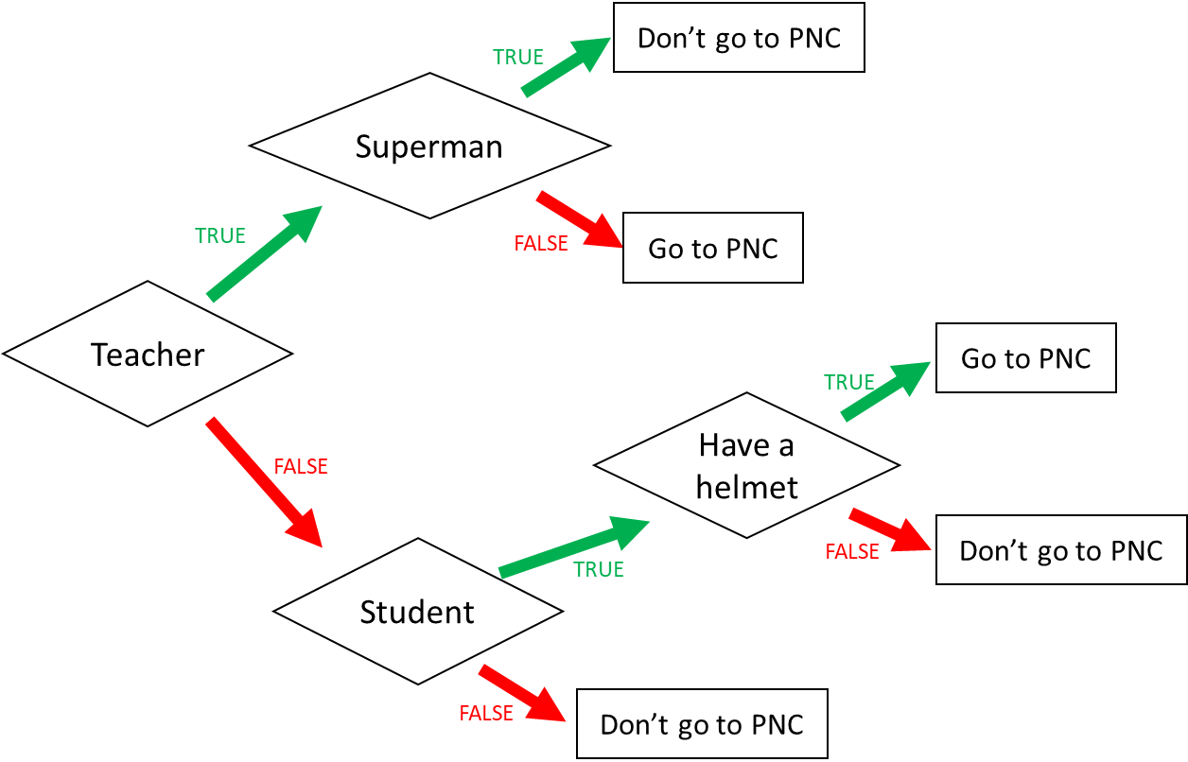

1. I am a teacher and I am superman, can I go to PNC?

not

1. I am not a teacher and not a student, can I go to PNC?

not

1. When can I go to PNC? (Express the condition using a Boolean expression)

I go to PNC if:

( I am a teacher and I am not superman) or

( Not teacher and student and Have a helmet )

Ex 2: What do I eat?

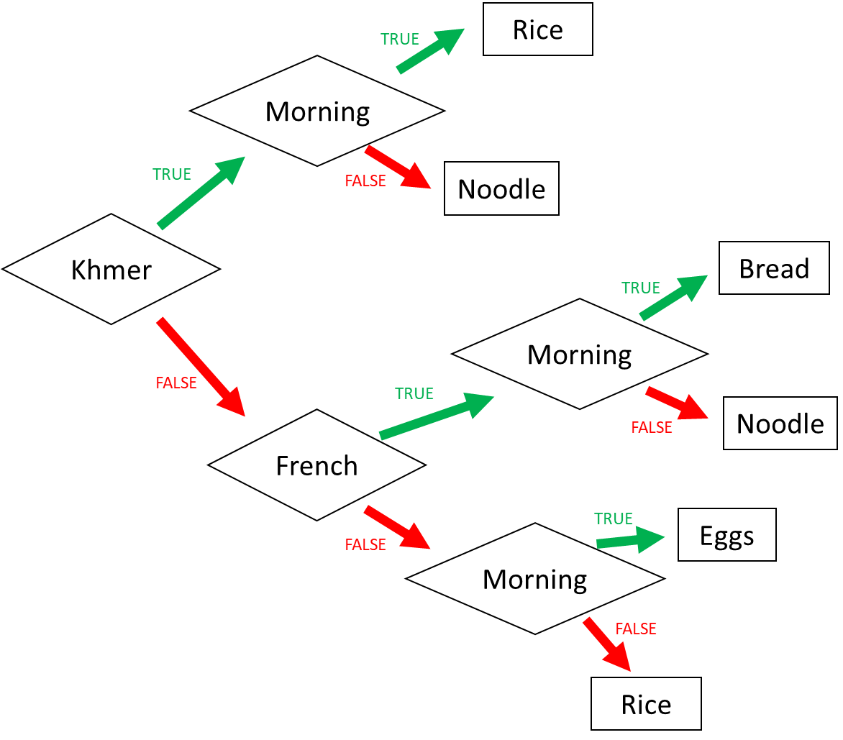

1. I am Khmer and it is the evening. What do I eat?

I eat noodle

2. I am French and it is the morning. What do I eat?

I eat bread

3. I am American and it is the morning. What do I eat?

I eat eggs

4. When do I eat rice? (Express the condition using a Boolean expression)

I eat rice if:

( I am khmer and morning )or( not khmer and not French and not morning)

Ex 3: Do I go to the pool?

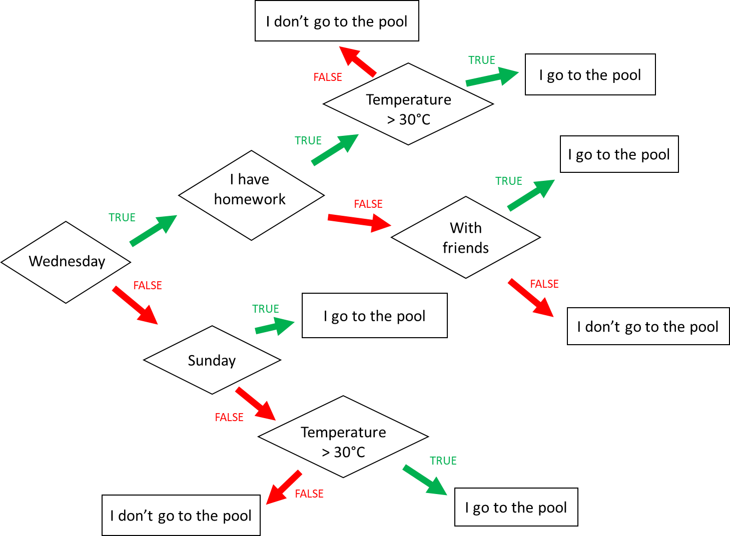

**Input 1 :**

* Wednesday
* Temperature = 31°C
* **Homework**

🡪 Do I go to the pool ?

(Not Wednesday and not Sunday)or( Wednesday and not I have homework)

**Input 2 :**

* Monday
* Temperature = 35°C
* I have no friend

🡪 Do I go to the pool ?

Not Sunday

**Input 3 :**

* Wednesday
* I have **no** homework
* I’m with friends
* Temperature = 28°C

🡪 Do I go to the pool ?

(Wednesday and not I have homework)or(Wednesday and I have homework)

When do I go to the pool ? (Express the condition using a Boolean expression)

I go to the pool if :

I go to the pool if

Wednesday and I have homework and Temperature=28OC

Ex4: Do I create a Facebook account?

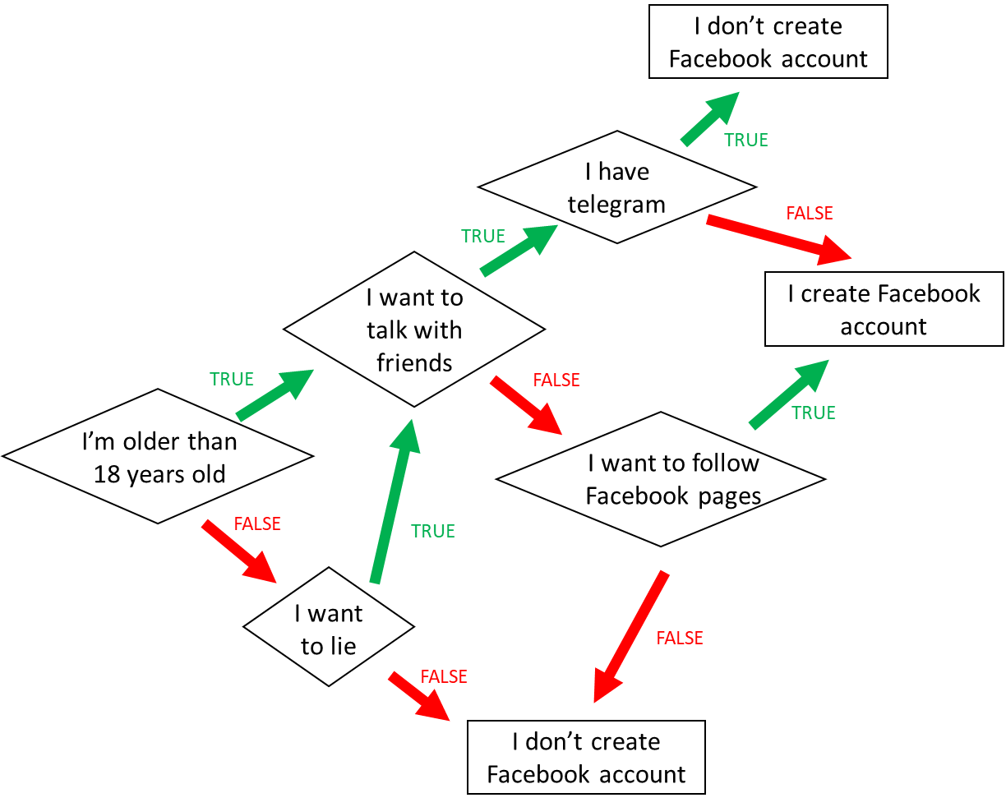

1. When do I create a Facebook account? (*Express the condition using a Boolean expression)*

I’m older than 18 years old and I want to talk with friends and I have telegram

I’m older than 18 years old and I want to talk with friends and not I have telegram

I’m older than 18 years old and not I want to lie

I’m older than 18 years old and not I want to lie and I want to talk with friends

1. When **don’t I** create a Facebook account? *(Express the condition using a Boolean expression)*

I’m older than 18 years old and I want to talk with friends and I have telegram

Ex5: Create the chart flow

**Q1** Complete the char flow to follow those rules:

* If I am a girl and it is sunny, I wear a skirt
* If I am a girl and it is not sunny, I wear jeans
* If I am a boy and it is sunny, I wear a short
* If I am a boy and it is not sunny, I wear jeans

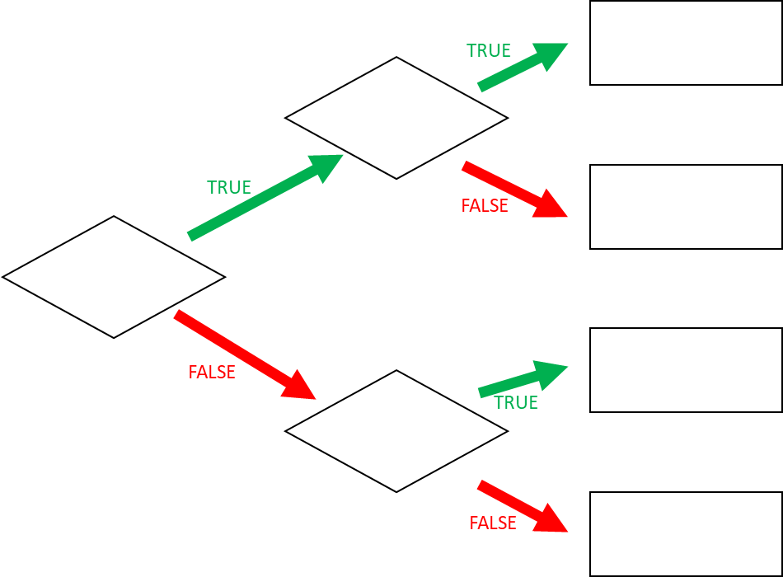

Girl

Short

Jeans

Skirt

Sunny

Jeans

Sunny

**Q1** When do I wear jeans? *(Express the condition using a Boolean expression)*

If I am a girl and it is not sunny

If I am a boy and it is not sunny